Step 1 - Register for a free account on Coding Rooms
https://app.codingrooms.com/signup

Step 2 - Click on this link to join our classroom
Coding Rooms
- 1. To see your code run step by step: Thonny, Python IDE for beginners
-2. https://pythontutor.com/

- Data science: https://hexaware.udemy.com/course/the-data-science-course-complete-data-science-bootcamp/learn/lecture/10799982#overview
3. sets 30 days of python: Day 11: Sets | Teclado
4. Formating string: Formatting Numbers for Printing in Python (teclado.com)
- Note:

- PEMDAS as per first preferance:
- Paranthesis ()
- Exponential **
- Multiplication *
- Division /
- Addition +
- Substraction –
- In keyword: used to check whether that particular element is present or not in lists, tuples and dictionaries.

- If you are using multiple “ ”, ‘ ‘ then to avoid error we use \
- \ will interpret as text in code.
Eg. print('You\'re at a crossroad, where do you want to go? "left" or "right"')
- Note: In for loop while creating dictionary eg. For name in dict_name:
Here name is the key and not value.
- \n – for new line
- + concatenation: Two strings added and there is no space in between.
Eg. Print(“Helllo” + “world”)
Op Helloworld
- Print(‘Hello “++++” world ’)
If you print something in single paranthesis it will treat whole statement as a single string.
- Input from user:
- input("What is your name?")
op. What is your name?Sanika
- print("Hello "+input("What is your name?"))
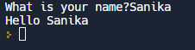

- # len() It will calculate length of string
print(len(input("What is your name? ")))
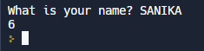
- Variables:
- It will print all number that are stored in same variable overriding will not happens
name='Jack'
print(name)
name='Andrew'
print(name)
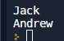
- name = input("What is your name? \n")
Length= len(name)
print(Length)
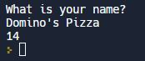
- Double number:
number=[1,2,3,4,5]
doubled_number=[x*2 for x in number]
print(doubled)
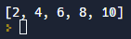
- Start with keyword:
friend=["Sam","Samantha","Rahul","Ram","Rinki"]
name=[x for x in friend if x.startswith("R")]
print(name)

or

friend=["Sam","Samantha","Rahul","Ram","Rinki"]
name=[]
for x in friend:
if x.startswith(x):
name.append(x)
print(name)
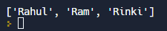
- Dict:
student={"Rolf":96,"bob":69,"Anne":90}
for x,y in student.items():
print(f"{x}: {y}")
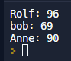
- Tuple:
student={"Rolf":96,"bob":69,"Anne":90}
print(list(student.items()))
for t in student.items():
print(t)
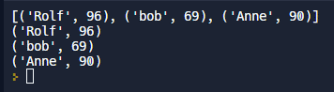
- Tuple(List):
people=[("Bob" , 42, "Mechanic"),("Anne", 30, "Engineer"),("Harry", 55, "Artist")]
for x in people:
print(f"Name= {x[0]} Age= {x[1]} Role= {x[2]}")
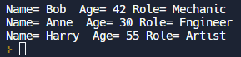
- Head,tail
head,*tail=[1,2,3,4,5]
print(head)
print(tail)
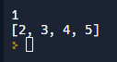
- Adding value into list:
friend=["Riya","Anne","Samantha"]
def add_friends():
name=input("Enter name= ")
friend.append(name)
print(friend)
add_friends()
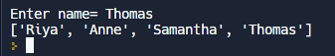
- Lambda Function:
- A lambda function is a different type of function which doesn’t have a name and is only used to return values.
- You can give them a name by assigning them into variable but they don’t have name in the function definition. They are used to return a value calculated by its parameters and its almost never used to perform actions
- x=lambda x, y: x+y
print(x(2,3))
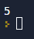
- lambda:
sequence=[1,3,5,7,9]
double=[(lambda x: x*2)(x) for x in sequence]
double=list(map(lambda x:x*2,sequence))
print(double)
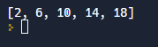
- Dictionary Comprehension:
users = [
(0, "Bob", "password"),
(1, "Rolf", "bob123"),
(2, "Jose", "longp4assword"),
(3, "username", "1234"),
]
username_mapping = {user[1]: user for user in users}
userid_mapping = {user[0]: user for user in users}
print(username_mapping)
print(username_mapping["Bob"]) # (0, "Bob", "password")
# -- Can be useful to log in for example --
username_input = input("Enter your username: ")
password_input = input("Enter your password: ")
_, username, password = username_mapping[username_input]
if password_input == password:
print("Your details are correct!")
else:
print("Your details are incorrect.")
# If we didn't use the mapping, the code would require us to loop over all users.
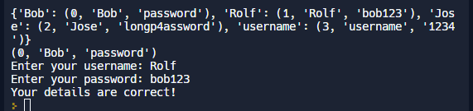
- a=input("a:")
b=input("b:")
c=a
a=b
b=c
print("a"+a)
print("b"+b)
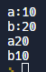
- Swapping
a=input("a:")
b=input("b:")
print("Before swapping" + "\n a:" +a+"\n b:"+ b)
c=a
a=b
b=c
print("\nAfter swapping"+"\n a:"+a+"\n b:"+b)
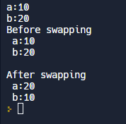

- name="hii {}, Today is {}"
var1=name.format("Bob","Friday")
print(var1)
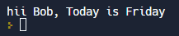

- List, Tuples, Sets:
List=[“ABC”,”PQR”,”XYZ”] # You can modify list, you can add, delete and update the list
Tuple=(“ABC”,”PQR”,”XYZ”) # You cannot modify tuples
Set={“ABC”,”PQR”,”XYZ”} # You can add and modify elements but you cannot have duplicate element in sets.
- List and Tuple have orders, but sets does not have order so we cannot print s[0] elements in sets.
- Calculating Difference:
friend={"Bob","Anne","Smith"}
abrod={"Smith","Bob"}
Local_friends=friend.difference(abrod)
print(Local_friends)
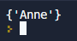

DAY 2:
- Adding string and integer
- # Stroring name of integer datatype into int_char variable
int_char = len(input("What is your name? \n"))
# Converting int into string
str_char= str(int_char)
# adding string and integer
print("Your has "+str_char+" character")
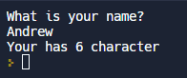

- Index
- Two_digit = input("Enter your value : \n")
first_num = int(Two_digit[0])
sec_num = int(Two_digit[1])
Two_digit = first_num + sec_num
print('Addition of first two index number')
print(Two_digit)
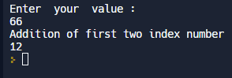

- Q.BMI calculator:
- height = input("enter your height in m: ")
weight = input("enter your weight in kg: ")
weight_as_int=int(weight)
height_as_float=float(height)
bmi = weight_as_int / height_as_float ** 2
bmi=weight_as_int/(height_as_float*height_as_float)
bmi_as_int = int(bmi)
print(bmi_as_int)
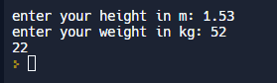

2.Eg .
h=input("Enter height=")
w=input("Enter weight=")
bmi_as_int=int(bmi)
print(bmi_as_int)
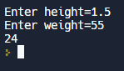

round(number: float) -> int
Round a number to a given precision in decimal digits.
The return value is an integer if ndigits is omitted or None. Otherwise the return value has the same type as the number. ndigits may be negative.
Eg. 1. print(round(8/3)) OP 3
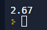
2. print(round(8/3,2))

- print( 8 // 3 )(flow division)
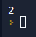
        - Flow division(//) will convert the datatype of value into INT.
        - Normally in division datatype of value will be float in division and if we are taking input from user then only string in other operations like +,-,*
score=0
print("Increment Operation")
score +=2
print(score)
print("decrement operation")
score-=1
print(score)
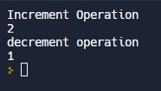

Note: - If you are printing string and integer, it will throw error
- You can print those value together by adding + sign but first you need convert integer into string.
Error.
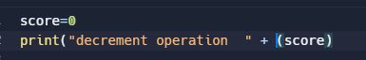
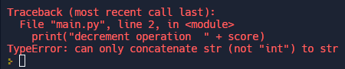

Corrected ans:
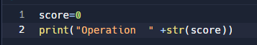
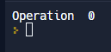

- You can use f=String for converting your datatype into string
score=20
height=1.5
winning=True
print(f" Your score is {score}\n Your height is {height}\n Your winning score is {winning}")
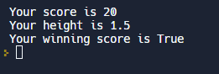

Q. Life In Week: https://waitbutwhy.com/2014/05/life-weeks.html

- age=int(input("What is your current age? \n"))
years_remaining=90-age
days_remaining=years_remaining*365
weeks_remaining=years_remaining*52
months_remaining=years_remaining*12
message=f" You have {days_remaining} \n days, {weeks_remaining} weeks,\n and {months_remaining} months left."
print(message)
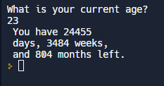
- print(6 + 4 / 2 - (1 * 2))
a = int("5") / int(2.7)
print(type(a))
print(a)
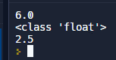

- Bill Tip Calculator
Eg. print("*****Welcome to tip calculator*****\n")
bill=float(input("Enter total bill amount in Rs.\n"))
tip=int(input("How much tip you want tp give ? \n 12 15 20 25\n"))
people=int(input("How many people will be spliting the bill?\n"))
# bil_with_percent= bill * (1 + tip / 100)
bill_with_percent=tip/100*bill+bill
bill_per_person=bill_with_percent/people
final_amount=round(bill_per_person,2)
# "{:.2f}" It will convert your float into string and give you 2 digits after decimal point like 20.00
final_amount="{:.2f}".format(bill_per_person)
print(f"Each person should pay Rs.{final_amount}")
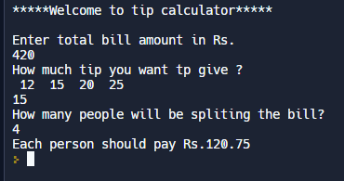

DAY 3:
https://replit.com/@appbrewery/treasure-island-end
drawing flowcharts and diagrams (draw.io): https://app.diagrams.net/

Conditional statement:
If-else:
If condition:
Do this
Else:
Do this
- Height calculator example
Eg. print("**** Welcome to rollercoster ride ****\n")
height=int(input("Enter your height\n"))
if height>=120:
print("You can ride")
else:
print("Sorry..! You cannont ride ")
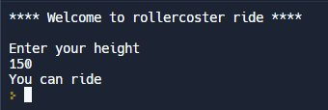

- Even or odd number
number=int(input("Enter Your Number\n"))
if number%2==0:
print("Your number is even")
else:
print("your number is odd")
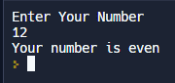
- Nested if-else
if condition1:
if condition2:
do this
else:
do this
else:
do this

Q. Height age calculator
print("**** Welcome to rollercoster ride ****\n")
height=int(input("Enter your height =\n"))
if height>=120:
age=int(input("Enter your age =\n"))
if age>20:
print("You have to pay 120.00 Rs.")
else:
print("You have to pay 100.00 Rs")
else:
print("Sorry..! You cannont ride ")
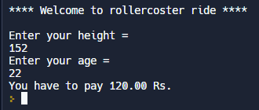

- If-elif-else:
if condition1:
do A
elif condition2:
do B
else:
do C
- Eg.
Age and height for rollercoster= calculate age between below 12 ,12-18 between and above 18.
print("**** Welcome to rollercoster ride ****\n")
height=int(input("Enter your height =\n"))
if height>=120:
age=int(input("Enter your age= "))
if age<12:
print("You should pay 100.00 Rs")
elif age<=18:
print("You should pay 150.00 Rs")
else:
print("You should pay 200.00 Rs")
else:
print("You are not allowed")
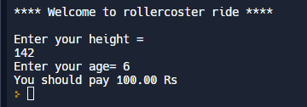

Q. BMI calculator 2.0
height=float(input("enter your height = "))
weight=float(input("Enter your weight = "))
bmi=round(weight/height ** 2)
if bmi<18.5:
print(f"{bmi} is your bmi and you are underweight")
elif bmi<25:
print(f"{bmi} is your bmi and you are having normal weight")
elif bmi <30:
print(f"{bmi} is your bmi and You are overweight")
elif bmi<35:
print(f"{bmi} is your bmi and you are obese")
else:
print(f"{bmi} is your bmi and you are clinically obese")
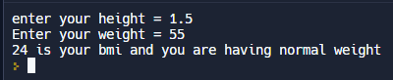
Q. Leap Year
year=int(input("Enter your year = "))
if year % 4==0:
if year % 100==0:
if year % 400==0:
print(f"This is a leap year {year}")
else:
print(f"Not a leap year {year}")
else:
print(f"This is leap year {year}")
else:
print("This is not a leap year")
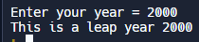

- If-elif-else
- Multiple if

- Q. Multiple if:
- Eg.
print("**Welcome to DIzzee World**")
height= float(input("Enter your height\n"))
age = int(input("Enter your age\n"))
bill=0
if height > 120:
if age < 12:
bill= 50
print("You are eligible and your amount to paid is 50.00 Rs")
elif age <= 18:
bill=100
print("You are eligible and your amount to paid is 100.00 Rs")
else:
bill=150
print("Yor are eligible and your amount to paid is 150.00 Rs")
want_photo= input("Do you want photo ? Y or N\n")
if want_photo =="Y":
bill+=3
print(f"Your final bill is {bill}")
else:
print("You are not eligible")
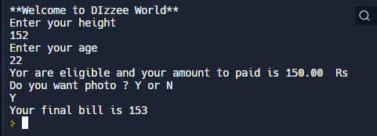

- Q. Pizza Order Program:
print("$$ Welcome to Python Pizza $$ \n")
size=input("What size you want ? S, M, L \n")
add_Pepperoni=input("Do you want Pepperoni ? Y, N \n")
add_cheese=input("Do you want Cheese ? Y, N\n")
bill=0
if size == "S":
bill+=120
elif size == "M":
bill+=150
elif size=="L":
bill+=200
else:
print("Please enter right pizza size")
if add_Pepperoni=="Y":
if size=="S":
bill+=15
else:
bill+=25
if add_cheese=="Y":
bill+=30
print(f"Your selected pizza size is {size}")
print(f"You have selected {add_Pepperoni} for pepperoni and\n {add_cheese} for cheese")
print(f"Your Final amount for Pizza is {bill}")
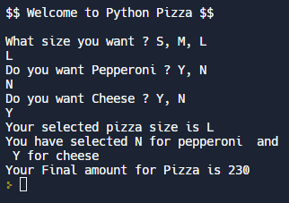

- Love Calculator;
print("*** Welcome to Love calculator *** \n")
name1=input("Enter your first name \n")
name2=input("Enter your second name \n")
combined_name= name1 + name2
lower_combined_name=combined_name.lower()
t=lower_combined_name.count("t")
r=lower_combined_name.count("r")
u=lower_combined_name.count("u")
e=lower_combined_name.count("e")
true=t+r+u+e
l=lower_combined_name.count("l")
o=lower_combined_name.count("o")
v=lower_combined_name.count("v")
e=lower_combined_name.count("e")
love=l+o+v+e
#love_score=int(str(true)+ str(love))
love_score= str(true)+ str(love)
int_love_score=int(love_score)
if (int_love_score <10) or (int_love_score>90):
print(f"your score is {int_love_score} and You go together like coke and coffee")
elif (int_love_score<=40) and (int_love_score>=50):
print(f"Your love score is {int_love_score} and you go together alright")
else:
print(f"Your score is {int_love_score}")
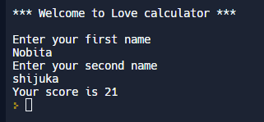
- Treasure- Island-end
https://ascii.co.uk/art
Eg.
print(''' *******************************************************************************
| | | |
_________|________________.=""_;=.______________|_____________________|_______
| | ,-"_,="" `"=.| |
|___________________|__"=._o`"-._ `"=.______________|___________________
| `"=._o`"=._ _`"=._ |
_________|_____________________:=._o "=._."_.-="'"=.__________________|_______
| | __.--" , ; `"=._o." ,-"""-._ ". |
|___________________|_._" ,. .` ` `` , `"-._"-._ ". '__|___________________
| |o`"=._` , "` `; .". , "-._"-._; ; |
_________|___________| ;`-.o`"=._; ." ` '`."\` . "-._ /_______________|_______
| | |o; `"-.o`"=._`` '` " ,__.--o; |
|___________________|_| ; (#) `-.o `"=.`_.--"_o.-; ;___|___________________
____/______/______/___|o;._ " `".o|o_.--" ;o;____/______/______/____
/______/______/______/_"=._o--._ ; | ; ; ;/______/______/______/_
____/______/______/______/__"=._o--._ ;o|o; _._;o;____/______/______/____
/______/______/______/______/____"=._o._; | ;_.--"o.--"_/______/______/______/_
____/______/______/______/______/_____"=.o|o_.--""___/______/______/______/____
/______/______/______/______/______/______/______/______/______/______/[TomekK]
******************************************************************************* ''')

print("***$$ Welcome to treasure Island $$**** \n")
print("Your job is to find treasure")
choice1=input('You\'re at a crossroad, where do you want to go? type "left" or "right"\n').lower()
if choice1 == "left":
choice2=input('You\'ve come to a lake. There is an island in the middle of the lake\n Type "Wait" to wait for boat or type "Swim" to swim into lake\n').lower()
if choice2=="wait":
print("You have arrived at island.There is a house with 3 doors.")
choice3=input("Choose one door among Red , Green and Yellow\n").lower()
if choice3=="Yellow":
print("You have reached the island.\n****You Won the Game****")
elif choice3=="Red":
print("This room is full of Beast. Game Over...!!!")
elif choice3=="Green":
print("This room is full of fire. Game Over...!!!")
else:
print("You choose the door that dosent exist. Game Over...!!!")
else:
print("You have attacked by angry crocodile. Game Over...!!!")
else:
print("You fell into hole. Game Over...!!!")
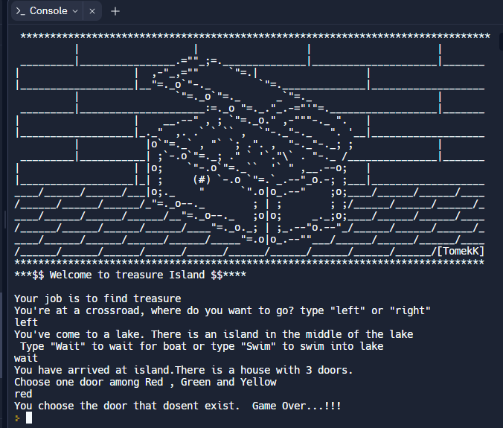

DAY 4:
- Randomisation and python list:
- In this program we are importing random module and randint() is a function which will print any random value between 1 to 10.
Eg. import random
random_integer= random.randint(1,10)
print(random_integer)
- List: https://docs.python.org/3/tutorial/datastructures.html
- It is just way of storing and organizing the data in python.
Eg. Fruit=[Item1, Item2]

Q. Who will pay the bill?
- list, choice(), len(), random, split()
import random
names_string=input("Give me everybodys name that are separated by comma\n")
names=names_string.split(", ")
length_calc=len(names)
random_choice=random.randint(0,length_calc-1)
person=names[random_choice]
print(person+" is goingto pay the bill")

or
import random
enter_name=input("Enter names\n")
name_split=enter_name.split(", ")
person=random.choice(name_split)
print(person +" will pay bill")
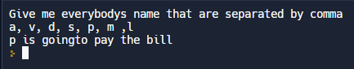

Q. Finding Treasure
list1=["*", "*", "*"]
list2=["*", "*", "*"]
list3=["*", "*", "*"]
all_list=[list1,list2,list3]
print(f"{list1}\n{list2}\n{list3}")
position=input("where do you want to put value\n")
Horizontal=int(position[0])
verticle=int(position[1])
selected_row=int(position[1])
selected_row=all_list[verticle-1]
selected_row[Horizontal-1]="X"
#all_list[verticle-1][horizontal-1]="X"
print(f"{list1}\n{list2}\n{list3}")
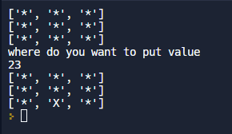

Q. Rock Paper scissor
import random
print("***Welcome to Rock Paper Scissor game***\n")
rock = '''
_______
---' ____)
(_____)
(_____)
(____)
---.__(___)
'''

paper = '''
_______
---' ____)____
______)
_______)
_______)
---.__________)
'''

scissors = '''
_______
---' ____)____
______)
__________)
(____)
---.__(___)
'''
game_image=[rock, paper, scissors]
User_choice=int(input("What you will choose?\nType 0 for rock, 1 for paper and 2 for Scissor\n"))
if User_choice>=3 or User_choice<0:
print("You typed an invalid number, you lose!")
else:
print(game_image[User_choice])
computer_choice=random.randint(0,2)
print("Computer choose :")
print(game_image[computer_choice])
if User_choice==0 and computer_choice==2:
print("You Win !")
elif computer_choice==0 and User_choice==2:
print("You lose !")
elif computer_choice>User_choice:
print("You lose !")
elif User_choice>computer_choice:
print("You Win !")
elif computer_choice==User_choice:
print("Your match is draw !")

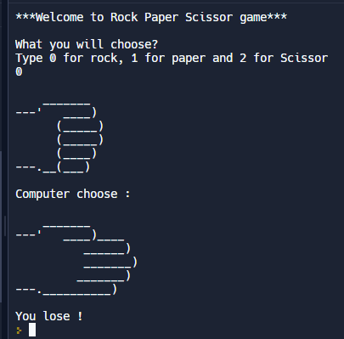

DAY 5:
For Loop:
- Height Calculator:
student_height=input("Enter studnts height\n").split()
for n in range(0,len(student_height)):
student_height[n]=int(student_height[n])
total_height=0
for height in student_height:
total_height+=height
print(f"Total Height= {total_height}")
number_of_students=0
for student in student_height:
number_of_students+=1
print(f"Number of students= {number_of_students}")
average_height= round(total_height/number_of_students)
print(f"Average Height= {average_height}")
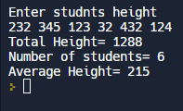
Q. High Score:
student_score=input("Enter students score\n").split()
for n in range(0,len(student_score)):
student_score[n]=int(student_score[n])
print(f"Students score= {student_score}")
highest_score=0
for score in student_score:
if score>highest_score:
highest_score=score
print(f"The highest score in class is {highest_score}")
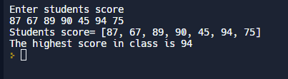

Q. Addition of number:
total=0
for n in range(1,101):
total+=n
print(f"Total of 1 to 100 number is {total}\n\n")
for n in range(1,11,3):
print(f"Numbers bwtween 1 to 10 with difference of 2 are {n}")
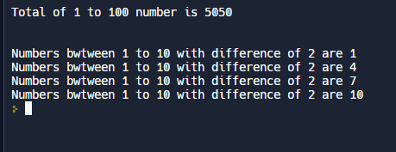

Q. Addition of evens:
total=0
for n in range(2,101,2):
total+=n
print(f"Total of 1 to 100 number is {total}\n\n")
total2=0
for n in range(1,101):
if n %2==0:
total2+=n
print(f"Total even number={total2}")
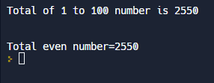

Q. Fizz Buzz:

for n in range(1,20):
if n%3==0 and n%5==0:
print("FizzBuzz")
elif n%3==0:
print("Fizz")
elif n%5==0:
print("Buzz")
else:
print(n)
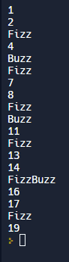

Q. Create a Password generator:

#Password Generator Project
import random
letters = ['a', 'b', 'c', 'd', 'e', 'f', 'g', 'h', 'i', 'j', 'k', 'l', 'm', 'n', 'o', 'p', 'q', 'r', 's', 't', 'u', 'v', 'w', 'x', 'y', 'z', 'A', 'B', 'C', 'D', 'E', 'F', 'G', 'H', 'I', 'J', 'K', 'L', 'M', 'N', 'O', 'P', 'Q', 'R', 'S', 'T', 'U', 'V', 'W', 'X', 'Y', 'Z']
numbers = ['0', '1', '2', '3', '4', '5', '6', '7', '8', '9']
symbols = ['!', '#', '$', '%', '&', '(', ')', '*', '+']

print("Welcome to the PyPassword Generator!")
nr_letters = int(input("How many letters would you like in your password?\n"))
nr_symbols = int(input(f"How many symbols would you like?\n"))
nr_numbers = int(input(f"How many numbers would you like?\n"))

#Eazy Level
# password = ""

# for char in range(1, nr_letters + 1):
# password += random.choice(letters)

# for char in range(1, nr_symbols + 1):
# password += random.choice(symbols)

# for char in range(1, nr_numbers + 1):
# password += random.choice(numbers)

# print(password)

#Hard Level
password_list = []

for char in range(1, nr_letters + 1):
password_list.append(random.choice(letters))

for char in range(1, nr_symbols + 1):
password_list += random.choice(symbols)

for char in range(1, nr_numbers + 1):
password_list += random.choice(numbers)

print(password_list)
random.shuffle(password_list)
print(password_list)
#Converting into string
password = ""
for char in password_list:
password += char

print(f"Your password is: {password}")
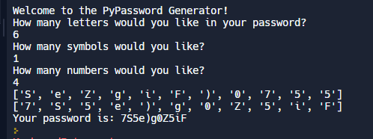

DAY 6
- Function: https://docs.python.org/3/library/functions.html
def my_function():
print("HII")
print("Hello")
my_function()

- ReeborgPlay::https://reeborg.ca/reeborg.html?lang=en&mode=python&menu=worlds%2Fmenus%2Freeborg_intro_en.json&name=Alone&url=worlds%2Ftutorial_en%2Falone.json

Q. hurdles Loop Challenge:
https://reeborg.ca/reeborg.html?lang=en&mode=python&menu=worlds%2Fmenus%2Freeborg_intro_en.json&name=Hurdle%201&url=worlds%2Ftutorial_en%2Fhurdle1.json

def turn_right():
turn_left()
turn_left()
turn_left()

def jump():
move()
turn_left()
move()
turn_right()
move()
turn_right()
move()
turn_left()

for steps in range(6):
jump()
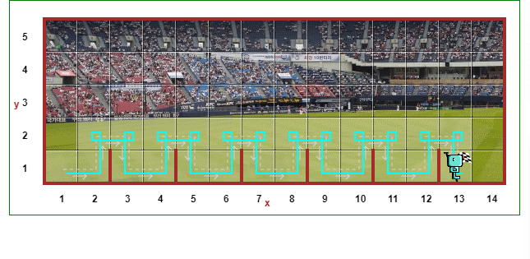
- While Loop:
- Syntax: While Something_that_is_true:
Do this
Or

def turn_right():
turn_left()
turn_left()
turn_left()

def jump():
move()
turn_left()
move()
turn_right()
move()
turn_right()
move()
turn_left()

step_for=6
while step_for>0:
jump()
step_for-=1
- Hurdle 2:
While not at_goal():
Jump()
- Hurdle 3:
- https://reeborg.ca/reeborg.html?lang=en&mode=python&menu=worlds%2Fmenus%2Freeborg_intro_en.json&name=Hurdle%203&url=worlds%2Ftutorial_en%2Fhurdle3.json
def turn_right():
turn_left()
turn_left()
turn_left()

def jump():
turn_left()
move()
turn_right()
move()
turn_right()
move()
turn_left()

while not at_goal():
if wall_in_front():
jump()
else:
move()
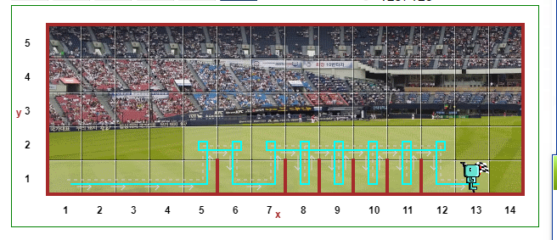
- Hurdle 4:
- https://reeborg.ca/reeborg.html?lang=en&mode=python&menu=worlds%2Fmenus%2Freeborg_intro_en.json&name=Hurdle%204&url=worlds%2Ftutorial_en%2Fhurdle4.json
def turn_right():
turn_left()
turn_left()
turn_left()

def jump():
turn_left()
while wall_on_right():
move()
turn_right()
move()
turn_right()
while front_is_clear():
move()
turn_left()

while not at_goal():
if wall_in_front():
jump()
else:
move()
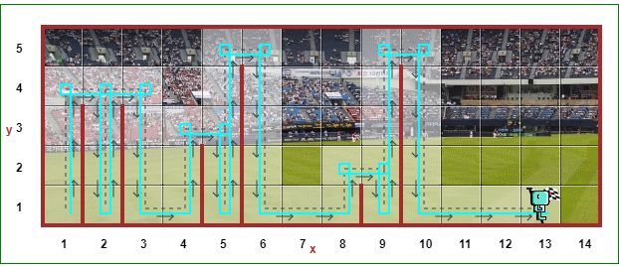

- Escaping Maze:
- https://reeborg.ca/reeborg.html?lang=en&mode=python&menu=worlds%2Fmenus%2Freeborg_intro_en.json&name=Maze&url=worlds%2Ftutorial_en%2Fmaze1.json

def turn_right():
turn_left()
turn_left()
turn_left()

while front_is_clear():
move()
turn_left()
while not at_goal():
if right_is_clear():
turn_right()
move()
elif:
front_is_clear()
move()
else:
turn_left()

DAY 7:
- Hangman Game:
- https://en.wikipedia.org/wiki/Hangman_(game)
- https://hangmanwordgame.com/?fca=1&success=0#/
Q. Picking a random word and checking:
- for loop with list: https://developers.google.com/edu/python/lists#for-and-in
#Step 1
word_list=["apple","banana","strawberry","pear"]
#TODO-1 - Randomly choose a word from the word_list and assign it to a variable called chosen_word.
import random
chosen_word=random.choice(word_list)
#TODO-2 - Ask the user to guess a letter and assign their answer to a variable called guess. Make guess lowercase.
guess=input("Guess a letter = ").lower()
#TODO-3 - Check if the letter the user guessed (guess) is one of the leters in the chosen_word.
for letters in chosen_word:
if letters==guess:
print("RIGHT...")
else:
print("WRONG...")

- Replacing blank with spaces:
- Range and while loop: https://developers.google.com/edu/python/lists#range
#Step 2

import random
word_list = ["aardvark", "baboon", "camel"]
chosen_word = random.choice(word_list)

#Testing code
print(f'Pssst, the solution is {chosen_word}.')

#TODO-1: - Create an empty List called display.
#For each letter in the chosen_word, add a "_" to 'display'.
#So if the chosen_word was "apple", display should be ["_", "_", "_", "_", "_"] with 5 "_" representing each letter to guess.

guess = input("Guess a letter: ").lower()

#TODO-2: - Loop through each position in the chosen_word;
#If the letter at that position matches 'guess' then reveal that letter in the display at that position.
#e.g. If the user guessed "p" and the chosen word was "apple", then display should be ["_", "p", "p", "_", "_"].
for letter in chosen_word:
if letter == guess:
print("Right")
else:
print("Wrong")

#TODO-3: - Print 'display' and you should see the guessed letter in the correct position and every other letter replace with "_".
#Hint - Don't worry about getting the user to guess the next letter. We'll tackle that in step 3.

- Replacing blank with letter:
#Step 2
import random
word_list = ["aardvark", "baboon", "camel"]
chosen_word = random.choice(word_list)

#Testing code
print(f'Pssst, the solution is {chosen_word}.')

#TODO-1: - Create an empty List called display.
#For each letter in the chosen_word, add a "_" to 'display'.
#So if the chosen_word was "apple", display should be ["_", "_", "_", "_", "_"] with 5 "_" representing each letter to guess.
display = []
word_length = len(chosen_word)
for _ in range(word_length):
display += "_"

guess = input("Guess a letter: ").lower()

#TODO-2: - Loop through each position in the chosen_word;
#If the letter at that position matches 'guess' then reveal that letter in the display at that position.
#e.g. If the user guessed "p" and the chosen word was "apple", then display should be ["_", "p", "p", "_", "_"].
for position in range(word_length):
letter = chosen_word[position]
#print(f"Current position: {position}\n Current letter: {letter}\n Guessed letter: {guess}")
if letter == guess:
display[position] = letter

#TODO-3: - Print 'display' and you should see the guessed letter in the correct position and every other letter replace with "_".
#Hint - Don't worry about getting the user to guess the next letter. We'll tackle that in step 3.
print(display)
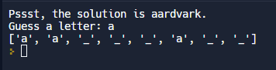

- Check Repeatedly for letters:
#Step 3

import random
word_list = ["aardvark", "baboon", "camel"]
chosen_word = random.choice(word_list)
word_length = len(chosen_word)

#Testing code
print(f'Pssst, the solution is {chosen_word}.')

#Create blanks
display = []
for _ in range(word_length):
display += "_"

#TODO-1: - Use a while loop to let the user guess again. The loop should only stop once the user has guessed all the letters in the chosen_word and 'display' has no more blanks ("_"). Then you can tell the user they've won.
end_of_game = False

while not end_of_game:
guess = input("Guess a letter: ").lower()

#Check guessed letter
for position in range(word_length):
letter = chosen_word[position]
#print(f"Current position: {position}\n Current letter: {letter}\n Guessed letter: {guess}")
if letter == guess:
display[position] = letter

print(display)

#Check if there are no more "_" left in 'display'. Then all letters have been guessed.
if "_" not in display:
end_of_game = True
print("You win.")
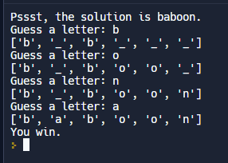
- How to check if Player Won?
#Step 3

import random
word_list = ["aardvark", "baboon", "camel"]
chosen_word = random.choice(word_list)
word_length = len(chosen_word)

#Testing code
print(f'Pssst, the solution is {chosen_word}.')

#Create blanks
display = []
for _ in range(word_length):
display += "_"

#TODO-1: - Use a while loop to let the user guess again. The loop should only stop once the user has guessed all the letters in the chosen_word and 'display' has no more blanks ("_"). Then you can tell the user they've won.
end_of_game = False

while not end_of_game:
guess = input("Guess a letter: ").lower()

#Check guessed letter
for position in range(word_length):
letter = chosen_word[position]
#print(f"Current position: {position}\n Current letter: {letter}\n Guessed letter: {guess}")
if letter == guess:
display[position] = letter

print(display)

#Check if there are no more "_" left in 'display'. Then all letters have been guessed.
if "_" not in display:
end_of_game = True
print("You win.")

- Keeping track of players life:
#Step 4

import random

stages = ['''
+---+
| |
O |
/|\ |
/ \ |
|
=========
''', '''
+---+
| |
O |
/|\ |
/ |
|
=========
''', '''
+---+
| |
O |
/|\ |
|
|
=========
''', '''
+---+
| |
O |
/| |
|
|
=========''', '''
+---+
| |
O |
| |
|
|
=========
''', '''
+---+
| |
O |
|
|
|
=========
''', '''
+---+
| |
|
|
|
|
=========
''']

end_of_game = False
word_list = ["ardvark", "baboon", "camel"]
chosen_word = random.choice(word_list)
word_length = len(chosen_word)

#TODO-1: - Create a variable called 'lives' to keep track of the number of lives left.
#Set 'lives' to equal 6.
lives = 6

#Testing code
print(f'Pssst, the solution is {chosen_word}.')

#Create blanks
display = []
for _ in range(word_length):
display += "_"

while not end_of_game:
guess = input("Guess a letter: ").lower()

#Check guessed letter
for position in range(word_length):
letter = chosen_word[position]
# print(f"Current position: {position}\n Current letter: {letter}\n Guessed letter: {guess}")
if letter == guess:
display[position] = letter

#TODO-2: - If guess is not a letter in the chosen_word,
#Then reduce 'lives' by 1.
#If lives goes down to 0 then the game should stop and it should print "You lose."
if guess not in chosen_word:
lives -= 1
if lives == 0:
end_of_game = True
print("You lose.")

#Join all the elements in the list and turn it into a String.
print(f"{' '.join(display)}")

#Check if user has got all letters.
if "_" not in display:
end_of_game = True
print("You win.")
- Main.py
#Step 5

import random

#TODO-1: - Update the word list to use the 'word_list' from hangman_words.py
#Delete this line: word_list = ["ardvark", "baboon", "camel"]
from hangman_words import word_list

chosen_word = random.choice(word_list)
word_length = len(chosen_word)

end_of_game = False
lives = 6

#TODO-3: - Import the logo from hangman_art.py and print it at the start of the game.
from hangman_art import logo
print(logo)

#Testing code
print(f'Pssst, the solution is {chosen_word}.')

#Create blanks
display = []
for _ in range(word_length):
display += "_"

while not end_of_game:
guess = input("Guess a letter: ").lower()

#TODO-4: - If the user has entered a letter they've already guessed, print the letter and let them know.
if guess in display:
print(f"You've already guessed {guess}")

#Check guessed letter
for position in range(word_length):
letter = chosen_word[position]
#print(f"Current position: {position}\n Current letter: {letter}\n Guessed letter: {guess}")
if letter == guess:
display[position] = letter

#Check if user is wrong.
if guess not in chosen_word:
#TODO-5: - If the letter is not in the chosen_word, print out the letter and let them know it's not in the word.
print(f"You guessed {guess}, that's not in the word. You lose a life.")

lives -= 1
if lives == 0:
end_of_game = True
print("You lose.")

#Join all the elements in the list and turn it into a String.
print(f"{' '.join(display)}")

#Check if user has got all letters.
if "_" not in display:
end_of_game = True
print("You win.")

#TODO-2: - Import the stages from hangman_art.py and make this error go away.
from hangman_art import stages
print(stages[lives])

#TODO-3: - print the ASCII art from 'stages' that corresponds to the current number of 'lives' the user has remaining.
print(stages[lives])

- Hangman_art.py
stages = ['''
+---+
| |
O |
/|\ |
/ \ |
|
=========
''', '''
+---+
| |
O |
/|\ |
/ |
|
=========
''', '''
+---+
| |
O |
/|\ |
|
|
=========
''', '''
+---+
| |
O |
/| |
|
|
=========''', '''
+---+
| |
O |
| |
|
|
=========
''', '''
+---+
| |
O |
|
|
|
=========
''', '''
+---+
| |
|
|
|
|
=========
''']

logo = '''
_
| |
| |__ __ _ _ __ __ _ _ __ ___ __ _ _ __
| '_ \ / _` | '_ \ / _` | '_ ` _ \ / _` | '_ \
| | | | (_| | | | | (_| | | | | | | (_| | | | |
|_| |_|\__,_|_| |_|\__, |_| |_| |_|\__,_|_| |_|
__/ |
|___/ '''

- Hangman_words.py
word_list = [

quis', 'matrix', 'megahertz', 'thumbscrew', 'topaz', 'transcript', 'transgress', 'transplant', 'triphthong', 'twelfth', 'twelfths', 'unknown',
'unworthy', 'unzip', 'uptown', 'vaporize', 'vixen', 'vodka', 'voodoo', 'vortex', 'voyeurism', 'walkway', 'waltz', 'wave', 'wavy', 'waxy', 'wellspring', 'wheezy', 'whiskey', 'whizzing', 'whomever', 'wimpy', 'witchcraft', 'wizard', 'woozy', 'wristwatch', 'wyvern', 'xylophone', 'yachtsman', 'yippee', 'yoked', 'youthful', 'yummy','zephyr', 'zigzag', 'zigzagging', 'zilch', 'zipper', 'zodiac', 'zombie',
]
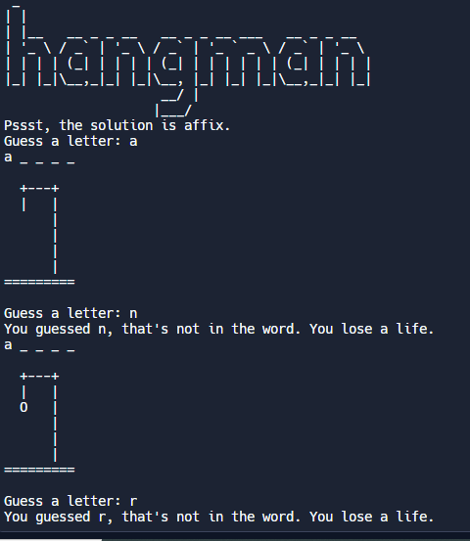
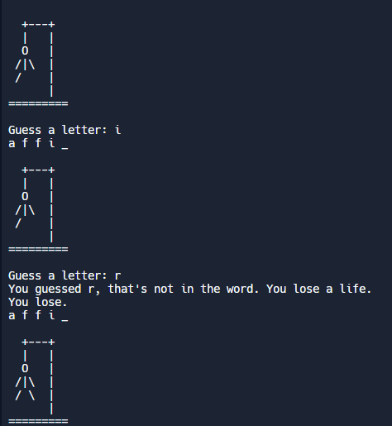

DAY 8: caesar-cipher
- Function with input:
- Positional argument:
def guess(a,b,c):
print(f"HEllo {a}")
print(f"where are u from {b}")
print(f"What is ur age {c}")
guess("Angela","India",20)
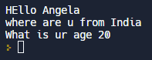
- Keyword argument:
def guess(a,b,c):
print(f"HEllo {a}")
print(f"where are u from {b}")
print(f"What is ur age {c}")
guess(a="Angela",c=20,b="India")
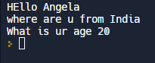
- Wall paint area Calculation:
- Math file is imported : math.ceil is used to convert decimal number into whole number
import math
def paint_calc(height,width,cover):
area=height*width
num_of_cans=math.ceil(area/cover)
#match.ceil() will convert decimal number into whole number
print(f"You will need {num_of_cans} cans of paint")
test_h=int(input("Enter height of wall = "))
test_w=int(input("Enter width of wall = "))
coverage=5
paint_calc(height=test_h,width=test_w,cover=coverage)
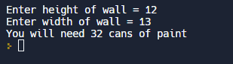

- Prime number checker:
Eg. 1,2,3,5,7,11
- Caeser Cipher: It is a way of encoding the message
- https://www.w3schools.com/python/ref_list_index.asp
- Art.py
logo = """
,adPPYba, ,adPPYYba, ,adPPYba, ,adPPYba, ,adPPYYba, 8b,dPPYba,
a8" "" "" `Y8 a8P_____88 I8[ "" "" `Y8 88P' "Y8
8b ,adPPPPP88 8PP""""""" `"Y8ba, ,adPPPPP88 88
"8a, ,aa 88, ,88 "8b, ,aa aa ]8I 88, ,88 88
`"Ybbd8"' `"8bbdP"Y8 `"Ybbd8"' `"YbbdP"' `"8bbdP"Y8 88
88 88
"" 88
88
,adPPYba, 88 8b,dPPYba, 88,dPPYba, ,adPPYba, 8b,dPPYba,
a8" "" 88 88P' "8a 88P' "8a a8P_____88 88P' "Y8
8b 88 88 d8 88 88 8PP""""""" 88
"8a, ,aa 88 88b, ,a8" 88 88 "8b, ,aa 88
`"Ybbd8"' 88 88`YbbdP"' 88 88 `"Ybbd8"' 88
88
88
"""
- Main.py
alphabet = ['a', 'b', 'c', 'd', 'e', 'f', 'g', 'h', 'i', 'j', 'k', 'l', 'm', 'n', 'o', 'p', 'q', 'r', 's', 't', 'u', 'v', 'w', 'x', 'y', 'z', 'a', 'b', 'c', 'd', 'e', 'f', 'g', 'h', 'i', 'j', 'k', 'l', 'm', 'n', 'o', 'p', 'q', 'r', 's', 't', 'u', 'v', 'w', 'x', 'y', 'z']

def caesar(start_text, shift_amount, cipher_direction):
end_text = ""
if cipher_direction == "decode":
shift_amount *= -1
for char in start_text:
#TODO-3: What happens if the user enters a number/symbol/space?
#Can you fix the code to keep the number/symbol/space when the text is encoded/decoded?
#e.g. start_text = "meet me at 3"
#end_text = "•••• •• •• 3"
if char in alphabet:
position = alphabet.index(char)
new_position = position + shift_amount
end_text += alphabet[new_position]
else:
end_text += char
print(f"Here's the {cipher_direction}d result: {end_text}")

#TODO-1: Import and print the logo from art.py when the program starts.
from art import logo
print(logo)

#TODO-4: Can you figure out a way to ask the user if they want to restart the cipher program?
#e.g. Type 'yes' if you want to go again. Otherwise type 'no'.
#If they type 'yes' then ask them for the direction/text/shift again and call the caesar() function again?
#Hint: Try creating a while loop that continues to execute the program if the user types 'yes'.
should_end = False
while not should_end:

direction = input("Type 'encode' to encrypt, type 'decode' to decrypt:\n")
text = input("Type your message:\n").lower()
shift = int(input("Type the shift number:\n"))
#TODO-2: What if the user enters a shift that is greater than the number of letters in the alphabet?
#Try running the program and entering a shift number of 45.
#Add some code so that the program continues to work even if the user enters a shift number greater than 26.
#Hint: Think about how you can use the modulus (%).
shift = shift % 26

caesar(start_text=text, shift_amount=shift, cipher_direction=direction)

restart = input("Type 'yes' if you want to go again. Otherwise type 'no'.\n")
if restart == "no":
should_end = True
print("Goodbye")
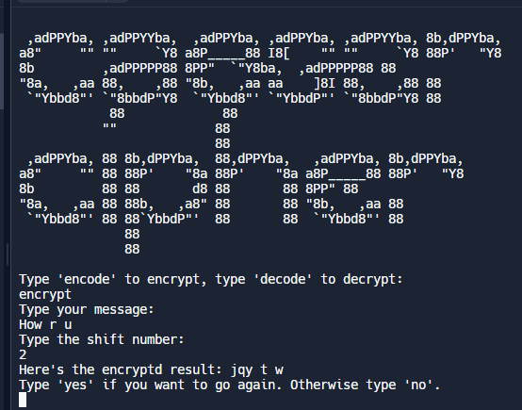

DAY 9
- Dictionaries and nesting:
- Dictionaries={Key:value}
- Note: In for loop while creating dictionary eg. For name in dict_name:
Here name is the key and not value.
- Dictionaries have element that are identified by their keys.
- Each Key have only one value, if youwant to assign multiple values to each key you can use list as values for one key
programming_dict={"Name":"Sanika",
"Age":20,
"City":"Satara"}
for key in programming_dict:
print(key)
print(f"{programming_dict[key]}\n")
print(programming_dict)
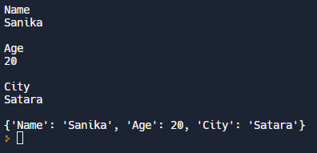

- Grading Program:
student_scores = {
"Harry": 81,
"Ron": 78,
"Hermione": 99,
"Draco": 74,
"Neville": 62,
}
#TODO-1: Create an empty dictionary called student_grades.
student_grades = {}

#TODO-2: Write your code below to covert scores into grades.👇
for student in student_scores:
score = student_scores[student]
if score > 90:
student_grades[student] = "Outstanding"
elif score > 80:
student_grades[student] = "Exceeds Expectations"
elif score > 70:
student_grades[student] = "Acceptable"
else:
student_grades[student] = "Fail"
print(student_grades)

- Nested :
##Python Dictionaries

programming_dictionary = {
"Bug": "An error in a program that prevents the program from running as expected.",
"Function": "A piece of code that you can easily call over and over again.",
}

#Retrieving items from dictionary.
# print(programming_dictionary["Function"])

#Adding new items to dictionary.
programming_dictionary["Loop"] = "The action of doing something over and over again."

#Create an empty dictionary.
empty_dictionary = {}

#Wipe an existing dictionary
# programming_dictionary = {}
# print(programming_dictionary)

#Edit an item in a dictionary
programming_dictionary["Bug"] = "A moth in your computer."
# print(programming_dictionary)

#Loop through a dictionary
# for key in programming_dictionary:
# print(key)
# print(programming_dictionary[key])

#Nesting
capitals = {
"France": "Paris",
"Germany": "Berlin",
}

#Nesting a List in a Dictionary

travel_log = {
"France": ["Paris", "Lille", "Dijon"],
"Germany": ["Berlin", "Hamburg", "Stuttgart"],
}

#Nesting Dictionary in a Dictionary

travel_log = {
"France": {"cities_visited": ["Paris", "Lille", "Dijon"], "total_visits": 12},
"Germany": {"cities_visited": ["Berlin", "Hamburg", "Stuttgart"], "total_visits": 5},
}

#Nesting Dictionaries in Lists

travel_log = [
{
"country": "France",
"cities_visited": ["Paris", "Lille", "Dijon"],
"total_visits": 12,
},
{
"country": "Germany",
"cities_visited": ["Berlin", "Hamburg", "Stuttgart"],
"total_visits": 5,
},
]
- Travel log:
travel_log = [
{
"country": "France",
"visits": 12,
"cities": ["Paris", "Lille", "Dijon"]
},
{
"country": "Germany",
"visits": 5,
"cities": ["Berlin", "Hamburg", "Stuttgart"]
},
]
#TODO: Write the function that will allow new countries
#to be added to the travel_log.
def add_new_country(name, visit_count, cities_visited):
new_country = {}
new_country["country"] = name
new_country["visits"] = visit_count
new_country["cities"] = cities_visited
travel_log.append(new_country)
add_new_country("Russia", 2, ["Moscow", "Saint Petersburg"])
print(travel_log)
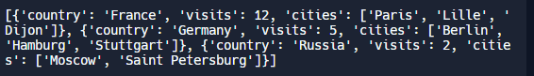

- Auction Program:
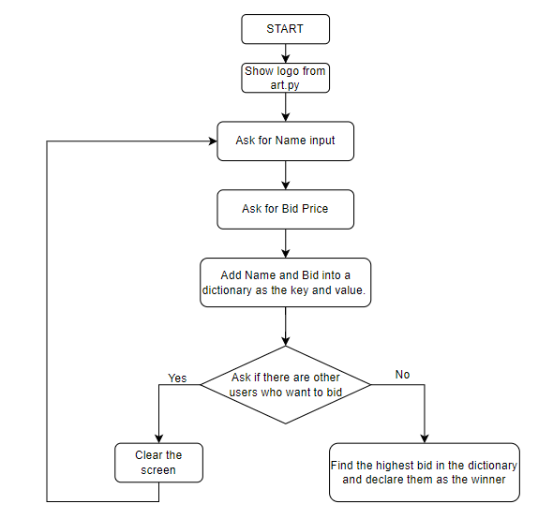
- Art.py
logo = '''
___________
\ /
)_______(
|"""""""|_.-._,.---------.,_.-._
| | | | | | ''-.
| |_| |_ _| |_..-'
|_______| '-' `'---------'` '-'
)"""""""(
/_________\\
.-------------.
/_______________\\
'''

- Main.py
from replit import clear
from art import logo
print(logo)

bids = {}
bidding_finished = False

def find_highest_bidder(bidding_record):
highest_bid = 0
winner = ""
# bidding_record = {"Angela": 123, "James": 321}
for bidder in bidding_record:
bid_amount = bidding_record[bidder]
if bid_amount > highest_bid:
highest_bid = bid_amount
winner = bidder
print(f"The winner is {winner} with a bid of ${highest_bid}")

while not bidding_finished:
name = input("What is your name?: ")
price = int(input("What is your bid?: $"))
bids[name] = price
should_continue = input("Are there any other bidders? Type 'yes or 'no'.\n")
if should_continue == "no":
bidding_finished = True
find_highest_bidder(bids)
elif should_continue == "yes":
clear() 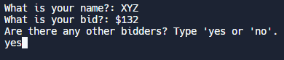
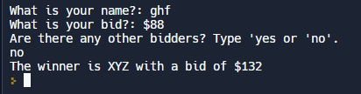

DAY 10:
- How to convert string to Title Case in Python?
https://stackoverflow.com/questions/8347048/how-to-convert-string-to-title-case-in-python
- def format_name(f_name,l_name):
formated_f_name=f_name.title()
formated_l_name=l_name.title()
return f"{formated_f_name} {formated_l_name}"
print(format_name("daTA","sCIence"))

- Multiple return() statement:
#Functions with Outputs
def format_name(f_name, l_name):
if f_name == "" or l_name == "":
return "You didn't provide valid inputs."
formated_f_name = f_name.title()
formated_l_name = l_name.title()
f"Result: {formated_f_name} {formated_l_name}"

#Storing output in a variable
formatted_name = format_name(input("Your first name: "), input("Your last name: "))
print(formatted_name)
#or printing output directly
print(format_name(input("What is your first name? "), input("What is your last name? ")))

#Already used functions with outputs.
length = len(formatted_name)

#Return as an early exit
def format_name(f_name, l_name):
"""Take a first and last name and format it
to return the title case version of the name."""
if f_name == "" or l_name == "":
return "You didn't provide valid inputs."
formated_f_name = f_name.title()
formated_l_name = l_name.title()
return f"Result: {formated_f_name} {formated_l_name}"

- Days in Months:
def is_leap(year):
if year%4==0:
if year%100==0:
if year%400==0:
return True
else:
return False
else:
return True
else:
return False
def days_in_months(year,month):
month_days=[31, 28, 31, 30, 31, 30, 31, 31, 30, 31, 30, 31]
if month==2 and is_leap(year):
return 29
return month_days[month-1]
year=int(input("Enter year = "))
month=int(input("Enter month = "))
days=days_in_months(year,month)
print(days)
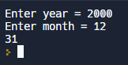

- Calculator:

def add(n1,n2):
return n1+n2
def substract(n1,n2):
return n1-n2
def multiply(n1,n2):
return n1*n2
def divide(n1,n2):
return n1/n2
operations={
"+":add,
"-":substract,
"*":multiply,
"/":divide
}
num1=int(input("Enter your first number = "))
num2=int(input("Enter your second number = "))
for symbol in operations:
print(symbol)
operation_symbol=input("Pick any one operation from above = ")

calculation_function=operations[operation_symbol]
answer=calculation_function(num1,num2)
print(f"{num1} {operation_symbol} {num2} = {answer}")
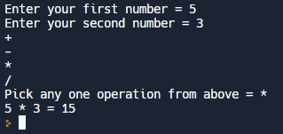
Or
- Art.py
logo = """
_____________________
| _________________ |
| | Pythonista 0. | | .----------------. .----------------. .----------------. .----------------.
| |_________________| | | .--------------. || .--------------. || .--------------. || .--------------. |
| ___ ___ ___ ___ | | | ______ | || | __ | || | _____ | || | ______ | |
| | 7 | 8 | 9 | | + | | | | .' ___ | | || | / \ | || | |_ _| | || | .' ___ | | |
| |___|___|___| |___| | | | / .' \_| | || | / /\ \ | || | | | | || | / .' \_| | |
| | 4 | 5 | 6 | | - | | | | | | | || | / ____ \ | || | | | _ | || | | | | |
| |___|___|___| |___| | | | \ `.___.'\ | || | _/ / \ \_ | || | _| |__/ | | || | \ `.___.'\ | |
| | 1 | 2 | 3 | | x | | | | `._____.' | || ||____| |____|| || | |________| | || | `._____.' | |
| |___|___|___| |___| | | | | || | | || | | || | | |
| | . | 0 | = | | / | | | '--------------' || '--------------' || '--------------' || '--------------' |
| |___|___|___| |___| | '----------------' '----------------' '----------------' '----------------'
|_____________________|
"""
- Main.py
from replit import clear
from art import logo

def add(n1, n2):
return n1 + n2

def subtract(n1, n2):
return n1 - n2

def multiply(n1, n2):
return n1 * n2

def divide(n1, n2):
return n1 / n2

operations = {
"+": add,
"-": subtract,
"*": multiply,
"/": divide
}

def calculator():
print(logo)

num1 = float(input("What's the first number?: "))
for symbol in operations:
print(symbol)
should_continue = True

while should_continue:
operation_symbol = input("Pick an operation: ")
num2 = float(input("What's the next number?: "))
calculation_function = operations[operation_symbol]
answer = calculation_function(num1, num2)
print(f"{num1} {operation_symbol} {num2} = {answer}")

if input(f"Type 'y' to continue calculating with {answer}, or type 'n' to start a new calculation: ") == 'y':
num1 = answer
else:
should_continue = False
clear()
calculator()
calculator()

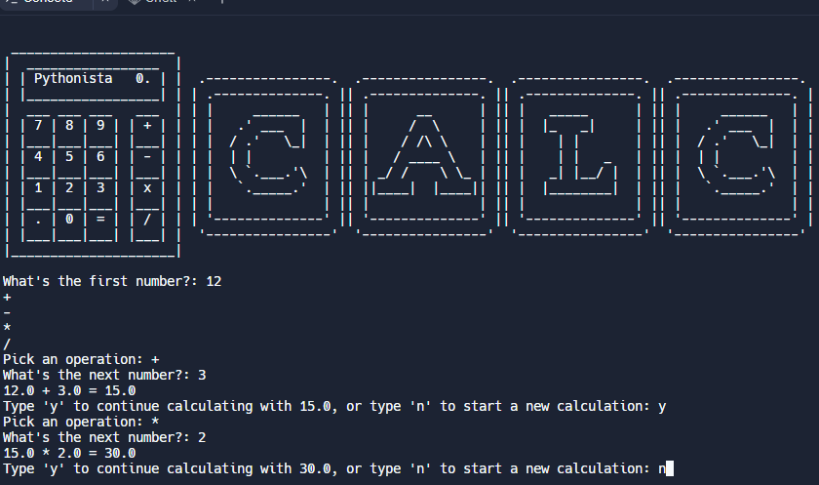

DAY 11:
- Blackjack Project
- Art.py
logo = """
.------. _ _ _ _ _
|A_ _ |. | | | | | | (_) | |
|( \/ ).-----. | |__ | | __ _ ___| | ___ __ _ ___| | __
| \ /|K /\ | | '_ \| |/ _` |/ __| |/ / |/ _` |/ __| |/ /
| \/ | / \ | | |_) | | (_| | (__| <| | (_| | (__| <
`-----| \ / | |_.__/|_|\__,_|\___|_|\_\ |\__,_|\___|_|\_\\
| \/ K| _/ |
`------' |__/
"""

############### Blackjack Project #####################

#Difficulty Normal 😎: Use all Hints below to complete the project.
#Difficulty Hard 🤔: Use only Hints 1, 2, 3 to complete the project.
#Difficulty Extra Hard 😭: Only use Hints 1 & 2 to complete the project.
#Difficulty Expert 🤯: Only use Hint 1 to complete the project.

############### Our Blackjack House Rules #####################

## The deck is unlimited in size.
## There are no jokers.
## The Jack/Queen/King all count as 10.
## The the Ace can count as 11 or 1.
## Use the following list as the deck of cards:
## cards = [11, 2, 3, 4, 5, 6, 7, 8, 9, 10, 10, 10, 10]
## The cards in the list have equal probability of being drawn.
## Cards are not removed from the deck as they are drawn.

##################### Hints #####################

#Hint 1: Go to this website and try out the Blackjack game:
# https://games.washingtonpost.com/games/blackjack/
#Then try out the completed Blackjack project here:
# http://blackjack-final.appbrewery.repl.run

#Hint 2: Read this breakdown of program requirements:
# http://listmoz.com/view/6h34DJpvJBFVRlZfJvxF
#Then try to create your own flowchart for the program.

#Hint 3: Download and read this flow chart I've created:
# https://drive.google.com/uc?export=download&id=1rDkiHCrhaf9eX7u7yjM1qwSuyEk-rPnt

#Hint 4: Create a deal_card() function that uses the List below to *return* a random card.
#11 is the Ace.
import random
from replit import clear
from art import logo

def deal_card():
"""Returns a random card from the deck."""
cards = [11, 2, 3, 4, 5, 6, 7, 8, 9, 10, 10, 10, 10]
card = random.choice(cards)
return card

#Hint 6: Create a function called calculate_score() that takes a List of cards as input
#and returns the score.
#Look up the sum() function to help you do this.
def calculate_score(cards):
"""Take a list of cards and return the score calculated from the cards"""

#Hint 7: Inside calculate_score() check for a blackjack (a hand with only 2 cards: ace + 10) and return 0 instead of the actual score. 0 will represent a blackjack in our game.
if sum(cards) == 21 and len(cards) == 2:
return 0
#Hint 8: Inside calculate_score() check for an 11 (ace). If the score is already over 21, remove the 11 and replace it with a 1. You might need to look up append() and remove().
if 11 in cards and sum(cards) > 21:
cards.remove(11)
cards.append(1)
return sum(cards)

#Hint 13: Create a function called compare() and pass in the user_score and computer_score. If the computer and user both have the same score, then it's a draw. If the computer has a blackjack (0), then the user loses. If the user has a blackjack (0), then the user wins. If the user_score is over 21, then the user loses. If the computer_score is over 21, then the computer loses. If none of the above, then the player with the highest score wins.
def compare(user_score, computer_score):
#Bug fix. If you and the computer are both over, you lose.
if user_score > 21 and computer_score > 21:
return "You went over. You lose 😤"

if user_score == computer_score:
return "Draw 🙃"
elif computer_score == 0:
return "Lose, opponent has Blackjack 😱"
elif user_score == 0:
return "Win with a Blackjack 😎"
elif user_score > 21:
return "You went over. You lose 😭"
elif computer_score > 21:
return "Opponent went over. You win 😁"
elif user_score > computer_score:
return "You win 😃"
else:
return "You lose 😤"

def play_game():

print(logo)

#Hint 5: Deal the user and computer 2 cards each using deal_card()
user_cards = []
computer_cards = []
is_game_over = False

for _ in range(2):
user_cards.append(deal_card())
computer_cards.append(deal_card())

#Hint 11: The score will need to be rechecked with every new card drawn and the checks in Hint 9 need to be repeated until the game ends.

while not is_game_over:
#Hint 9: Call calculate_score(). If the computer or the user has a blackjack (0) or if the user's score is over 21, then the game ends.
user_score = calculate_score(user_cards)
computer_score = calculate_score(computer_cards)
print(f" Your cards: {user_cards}, current score: {user_score}")
print(f" Computer's first card: {computer_cards[0]}")

if user_score == 0 or computer_score == 0 or user_score > 21:
is_game_over = True
else:
#Hint 10: If the game has not ended, ask the user if they want to draw another card. If yes, then use the deal_card() function to add another card to the user_cards List. If no, then the game has ended.
user_should_deal = input("Type 'y' to get another card, type 'n' to pass: ")
if user_should_deal == "y":
user_cards.append(deal_card())
else:
is_game_over = True

#Hint 12: Once the user is done, it's time to let the computer play. The computer should keep drawing cards as long as it has a score less than 17.
while computer_score != 0 and computer_score < 17:
computer_cards.append(deal_card())
computer_score = calculate_score(computer_cards)

print(f" Your final hand: {user_cards}, final score: {user_score}")
print(f" Computer's final hand: {computer_cards}, final score: {computer_score}")
print(compare(user_score, computer_score))

#Hint 14: Ask the user if they want to restart the game. If they answer yes, clear the console and start a new game of blackjack and show the logo from art.py.
while input("Do you want to play a game of Blackjack? Type 'y' or 'n': ") == "y":
clear()
play_game()

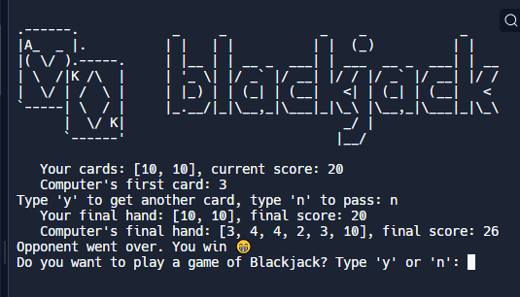
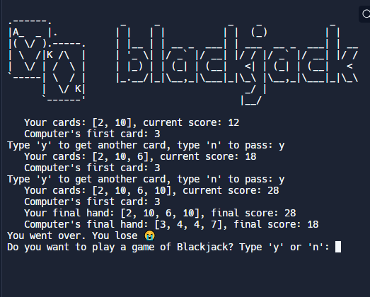

DAY 12:
- Scope: 1. Local scope 2. Global scope
- ################### Scope ####################
enemies = 1
def increase_enemies():
enemies = 2
print(f"enemies inside function: {enemies}")
increase_enemies()
print(f"enemies outside function: {enemies}")
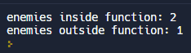

- # Local Scope

def drink_potion():
potion_strength = 2
print(potion_strength)

drink_potion()
print(potion_strength)

- # Global Scope
player_health = 10

def game():
def drink_potion():
potion_strength = 2
print(player_health)

drink_potion()

print(player_health)

# There is no Block Scope

game_level = 3

def create_enemy():
enemies = ["Skeleton", "Zombie", "Alien"]
if game_level < 5:
new_enemy = enemies[0]

print(new_enemy)

- # Modifying Global Scope

enemies = 1

def increase_enemies():
print(f"enemies inside function: {enemies}")
return enemies + 1

enemies = increase_enemies()
print(f"enemies outside function: {enemies}")

- #Global Constants

PI = 3.14159
URL = "https://www.google.com"
TWITTER_HANDLE = "@sanika"

- Guess the Number:
- Art.py
logo = """
/ _ \_ _ ___ ___ ___ /__ \ |__ ___ /\ \ \_ _ _ __ ___ | |__ ___ _ __
/ /_\/ | | |/ _ \/ __/ __| / /\/ '_ \ / _ \ / \/ / | | | '_ ` _ \| '_ \ / _ \ '__|
/ /_\\| |_| | __/\__ \__ \ / / | | | | __/ / /\ /| |_| | | | | | | |_) | __/ |
\____/ \__,_|\___||___/___/ \/ |_| |_|\___| \_\ \/ \__,_|_| |_| |_|_.__/ \___|_|
"""
- Main.py
from random import randint
from art import logo
EASY_LEVEL_TURNS = 10
HARD_LEVEL_TURNS = 5
#Function to check user's guess against actual answer.
def check_answer(guess, answer, turns):
"""checks answer against guess. Returns the number of turns remaining."""
if guess > answer:
print("Too high.")
return turns - 1
elif guess < answer:
print("Too low.")
return turns - 1
else:
print(f"You got it! The answer was {answer}.")
#Make function to set difficulty.
def set_difficulty():
level = input("Choose a difficulty. Type 'easy' or 'hard': ")
if level == "easy":
return EASY_LEVEL_TURNS
else:
return HARD_LEVEL_TURNS
def game():
print(logo)
#Choosing a random number between 1 and 100.
print("Welcome to the Number Guessing Game!")
print("I'm thinking of a number between 1 and 100.")
answer = randint(1, 100)
print(f"Pssst, the correct answer is {answer}")
turns = set_difficulty()
#Repeat the guessing functionality if they get it wrong.
guess = 0
while guess != answer:
print(f"You have {turns} attempts remaining to guess the number.")
#Let the user guess a number.
guess = int(input("Make a guess: "))
#Track the number of turns and reduce by 1 if they get it wrong.
turns = check_answer(guess, answer, turns)
if turns == 0:
print("You've run out of guesses, you lose.")
return
elif guess != answer:
print("Guess again.")
game()
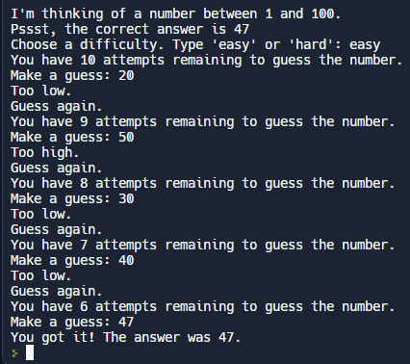

DAY 13:
- Debugging:
############DEBUGGING#####################

# # Describe Problem
# def my_function():
# for i in range(1, 20):
# if i == 20:
# print("You got it")
# my_function()

# # Reproduce the Bug
# from random import randint
# dice_imgs = ["❶", "❷", "❸", "❹", "❺", "❻"]
# dice_num =randint(1,5)
# print(dice_imgs[dice_num])

# # Play Computer
# year = int(input("What's your year of birth?"))
# if year >= 1980 and year <= 1994:
# print("You are a millenial.")
# elif year > 1994:
# print("You are a Gen Z.")

# # Fix the Errors
# age = int(input("How old are you?"))
# if age > 18:
# print(f"You can drive at age {age}.")

# #Print is Your Friend
# pages = 0
# word_per_page = 0
# pages = int(input("Number of pages: "))
# word_per_page = int(input("Number of words per page: "))
# total_words = pages * word_per_page
# print(total_words)

# #Use a Debugger
# def mutate(a_list):
# b_list = []
# for item in a_list:
# new_item = item * 2
# b_list.append(new_item)
# print(b_list)
# mutate([1,2,3,5,8,13])

Reference:
- (Psudo random number generator)Mersenne Twister(Wiki): https://en.wikipedia.org/wiki/Mersenne_Twister
- Mersenne Twister(Khan acadamy): https://www.khanacademy.org/computing/computer-science/cryptography/crypt/v/random-vs-pseudorandom-number-generators
- Python rando module method: https://www.askpython.com/python-modules/python-random-module-generate-random-numbers-sequences
- bradtraversy/python_sandbox: Files to learn Python basics (github.com)

